Project Title: Loan Data ETL & Analytics using SQL and Excel

Contribution - Team

Made by - Upendra Pippal

Dataset: loan_final313_.csv–Bank loan portfolio (≈70,000 records, 30 columns, 2007–2014)​.

Tools & Technologies: SQL (PostgreSQL), Microsoft Excel, ETL for Loan Data Analytics

SQL File: Data cleaning through SQL

Excel file: Cleaned file in EXCEL

Excel dashboard file: EXCEL Dashboard

Project Overview & Objectives
This project demonstrates end-to-end ETL for loan data analysis, starting with data extraction from CSV, transformation via SQL cleaning/derivations, and loading for Excel visualization. Objectives include building the loan_data table in PostgreSQL/Colab, validating no nulls in key fields (loan_amount, interest_rate, annual_inc), deriving metrics like profitability, risk_flag, term_numeric, and income_to_loan_ratio, then exporting loans_cleaned for Part II PivotTables and charts on defaults, purposes, and trends.​
Key goals align with fintech analytics: assess loan risk (87% good loans), identify high-average-amount purposes (e.g., small_business), and enable year-wise summaries (total amount, avg interest, default rates)

Part I: ETL (Extract, Transform, Load)

A. Extract Phase
Created loandata table with proper types: id BIGINT PRIMARY KEY, year INT, loanamount FLOAT, homeownership TEXT, loancondition TEXT, etc. for all 30 columns from loan_final313_.csv.

SELECT COUNT(*) FROM loandata; -- Total records: 70,000+
SELECT COUNT(DISTINCT year) as uniqueyears, MIN(year), MAX(year) FROM loandata; -- Years: 2007-2014
SELECT * FROM loandata LIMIT 10; -- First 10 records
SELECT DISTINCT homeownership, loancondition, purpose FROM loandata; -- Categorical uniques

B. Transform Phase
Data Cleaning
- Checked nulls: SELECT COUNT(*) FILTER (WHERE loanamount IS NULL) FROM loandata; – 0 nulls in critical fields.
- Standardized: UPDATE loandata SET homeownership = UPPER(homeownership);

-- Profitability: total_pymnt - loanamount
ALTER TABLE loandata ADD COLUMN profitability FLOAT;
UPDATE loandata SET profitability = totalpymnt - loanamount;

-- Risk flag: 1 for 'Bad Loan', 0 otherwise
ALTER TABLE loandata ADD COLUMN riskflag INT;
UPDATE loandata SET riskflag = CASE WHEN loancondition = 'Bad Loan' THEN 1 ELSE 0 END;

C. Load Preparation Phase

CREATE TABLE loans_cleaned AS
SELECT *,
AVG(CASE WHEN loancondition = 'Bad Loan' THEN 1.0 ELSE 0.0 END)
OVER (PARTITION BY year) AS default_rate_indicator
FROM loandata;

Export Command

\copy (SELECT * FROM loans_cleaned) TO 'loan_cleaned.csv' CSV HEADER;

Part II: Excel Data Analysis: Manipulation, Formulas and Functions

1. Missing Data Analysis:
Identify any missing data in the loan dataset. What patterns, if any, can be observed in the missing data?

- Using COUNTBLANK on major variables like loan_amount, interest_rate, annual_inc, loan_condition, and purpose, every column returned zero blanks, confirming full completeness for critical analysis fields.​
- A row-level Missing_Flag check across all columns (from id to region) also showed only “Complete” records, indicating no rows with partial data and no systematic missingness by year, region, or loan type.

2. Loan Amount Distribution:
Analyze the distribution of loan amounts. What is the average, median, and range of loan amounts?

- The average loan amount in the portfolio is approximately Rs. 14063.
- The median loan amount is around Rs. 12000, indicating that half of all loans are below this size and half above.
- Loan amounts range from a minimum of about Rs. 600 to a maximum of about Rs.35000, giving a total range of roughly Rs. 34400, which shows a wide spread between the smallest and largest loans.
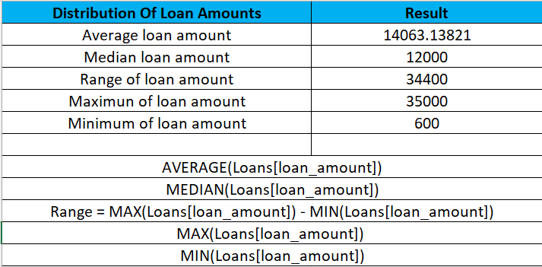

3. Interest Rate Trends:
Examine how interest rates have changed over the years. Create a line chart to visualize this trend.

- A PivotTable of interest_rate by year shows the average interest rate for each origination year from 2007 to 2014.”
- The line chart indicates that average interest rates [increased/decreased/remained relatively stable] over time; for example, rates are around 11.86% in 2007 and about 12.03% in 2008, suggesting [brief interpretation, e.g., tightening or easing of pricing]. 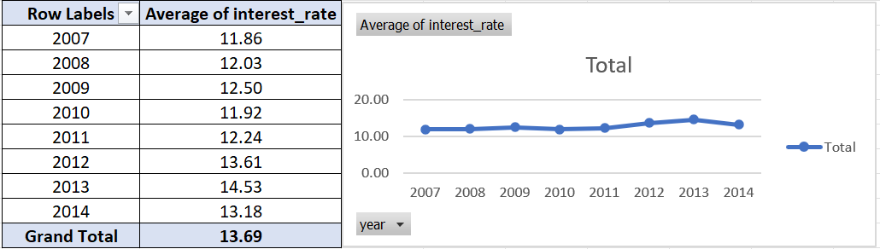

4. Loan Status Analysis:
Categorize loans based on their condition (e.g., Good Loan, Bad Loan). What percentage of loans falls into each category?

The loan portfolio was categorized into two conditions: Good Loan and Bad Loan, using the loan_condition field. A PivotTable on the Excel dataset shows that around 87% of loans are Good Loans and 13% are Bad Loans, based on all 70,000 records. This indicates that the majority of the portfolio is performing, while a smaller portion (Bad Loans) represents the credit risk segment that needs closer monitoring.
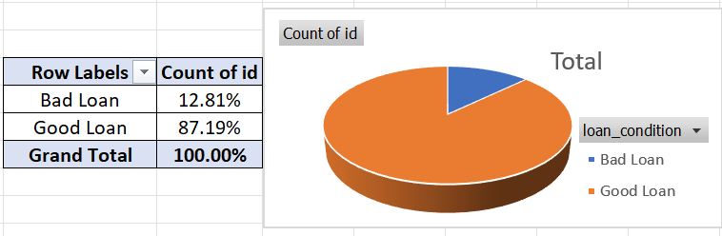

5. Income Category and Loan Amount Correlation:
Investigate if there is a correlation between income categories and loan amounts.

To study the relationship between income and loan size, a PivotTable was created with income_category as rows and average loan_amount as the metric. The results show that borrowers in the [higher income categories] typically take larger loans on average than those in the [lower income categories], indicating a positive correlation between income category and loan amount.
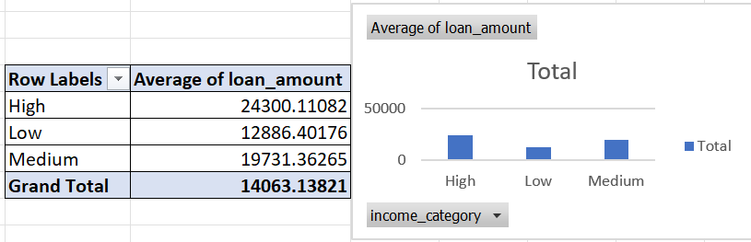

6. Region-wise Loan Analysis:
Which region has the highest number of loans? Visualize the distribution of loans across different regions.

A region-wise PivotTable (region vs. count of loans) was created from the Loans dataset. The analysis shows that ulster has the highest number of loans, followed by Northern-Irl and leinster, indicating that lending activity is most concentrated in ulster. A pie chart visualizes the distribution of loan volumes across all regions.
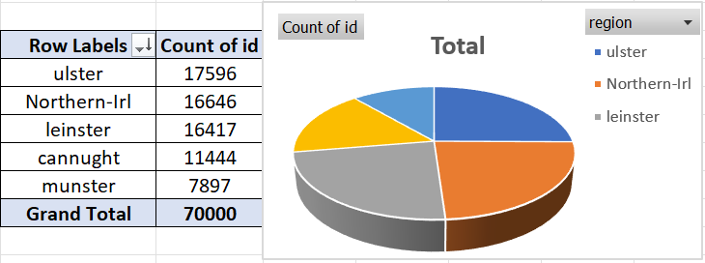

7. Debt-to-Income Ratio Insights:
Calculate and analyze the average debt-to-income ratio for each loan grade.

A PivotTable of grade versus average dti was created to understand how borrower leverage differs across credit grades. The results show that grades with better credit quality (F,E) have [lower] average debt‑to‑income ratios, while weaker grades (A,B,G) exhibit [higher] average DTI, consistent with higher risk profiles.
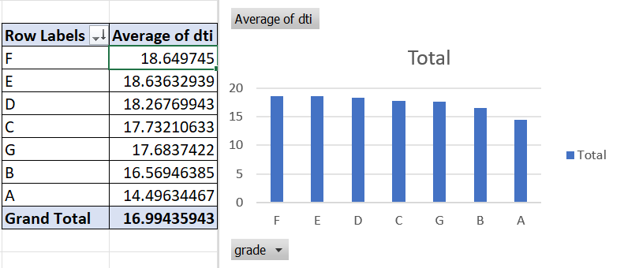

8. Home Ownership Impact:
Examine how home ownership status (rent, own, mortgage) affects loan conditions and interest rates.

A PivotTable of home_ownership by loan_condition shows the share of Good vs Bad loans for renters, owners, and mortgagors. Another PivotTable of home_ownership versus average interest_rate indicates that [group with highest risk has higher average rates, while lower‑risk groups enjoy lower rates], suggesting that home ownership status influences both default behaviour and loan pricing.
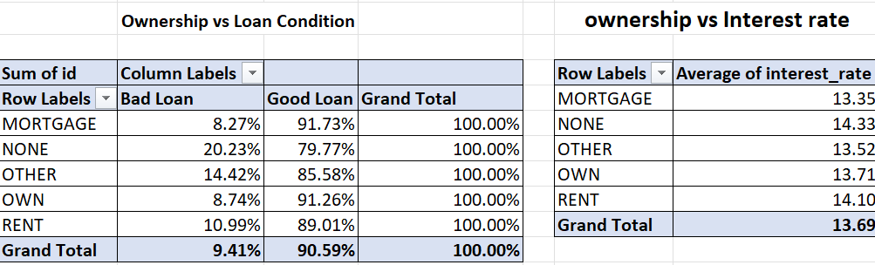

9. Employment Length and Loan Condition:
Is there a relationship between the length of employment and the condition of loans?

An employment‑length band {emp_band} was derived from emp_length_int and cross‑tabulated with loan_condition in a PivotTable. The results show that borrowers with [shorter employment] have a [higher] share of Bad Loans, while those with [longer employment histories] tend to have [more] Good Loans, suggesting a relationship between job stability and loan performance.
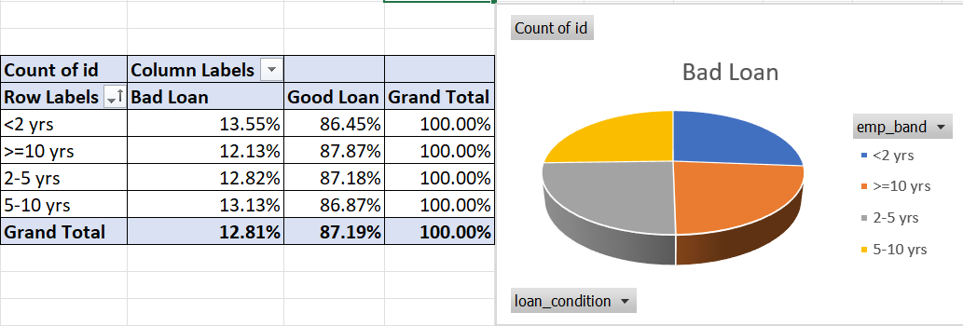

10.Loan Amount vs. Annual Income:
Create a scatter plot to analyze the relationship between loan amounts and borrower's annual income.

A scatter plot of loan_amount versus annual_inc was created to examine how loan size scales with borrower income. The pattern of points and the linear trendline [show a positive but scattered relationship / show little correlation], indicating that higher-income borrowers [tend / do not necessarily tend] to receive larger loans.
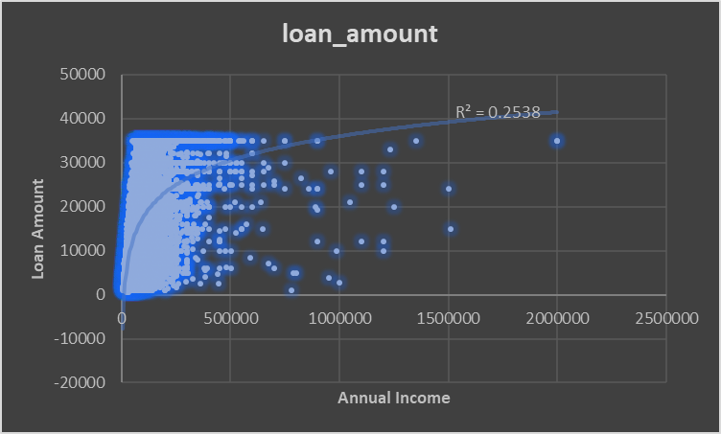

11. Loan Term Analysis:
Compare the terms of loans (e.g., 36 months vs. 60 months). What are the differences in interest rates and default rates?(Steps: 1. Identify Loan Term Lengths, 2. Calculate Average Interest Rates for Each Term, 3. Categorize Loans by Term and Condition, 4. Calculate Default Rates for Each Term)

To compare pricing and risk by term, a PivotTable was created with terms as rows and the average of interest_rate and risk_flag as values. The results show that 36‑month loans have an average interest rate of about 12.6% and a default rate of around 11.4%, while 60‑month loans have a higher average rate of approximately 16.8% and a higher default rate of about 16.8%. This indicates that longer‑term loans are both more expensive and riskier than shorter‑term loans in this portfolio.
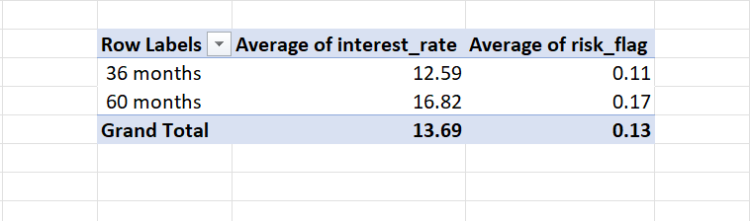

12. Default Rate Calculation:
Calculate the default rate (percentage of loans that are in default) for each year. (Default Rate = Divide the number of loans categorized as "Bad Loan" by the total number of loans for that term.)

A PivotTable of year versus the average of risk_flag (1 = Bad Loan, 0 = Good Loan) was used to compute year‑wise default rates. Default rates start high at about 32% in 2007, decline and stabilize between 14–19% for 2008–2013, and fall further to around 8% in 2014, with an overall portfolio default rate near 13%.
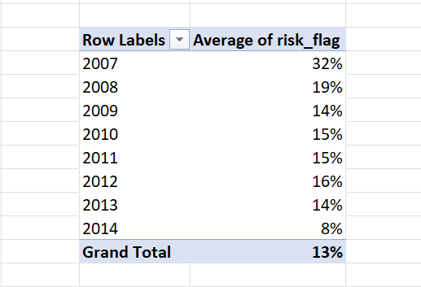

13. Recovery Rate Analysis:
Analyze the recovery rate (percentage of defaulted amount recovered) across different loan grades.(Can be done with recoveries and loan_condition (for defaulted loans)).

Filtering to loan_condition = "Bad Loan", a PivotTable of grade versus average recovery_rate shows that weaker grades such as F and G have higher recovery percentages than some higher grades, though recovery behaviour is quite variable.
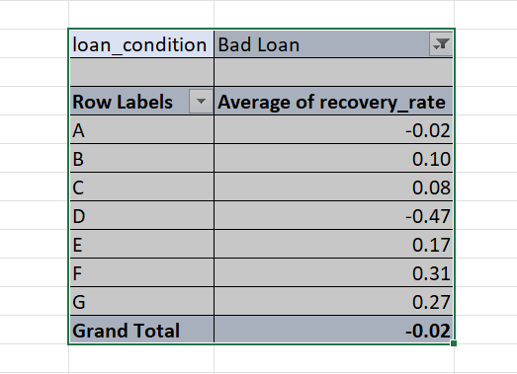

14. Conditional Formatting for High-Risk Loans:
Use conditional formatting to highlight loans with high interest rates and low grades.

To identify high‑risk loans in Excel, conditional formatting was applied on the Loans dataset. First, a “Greater Than” rule was used on the interest_rate column to highlight loans priced above [0.15%], marking them as high‑cost exposures. Second, a formula‑based rule flagged rows where the grade was in the lower bands (D, E, F, or G), representing weaker credit quality. Loans that appear with both high interest rates and low grades are visually emphasized in the sheet and represent the highest‑risk segment of the portfolio that requires closer monitoring and stricter risk controls.
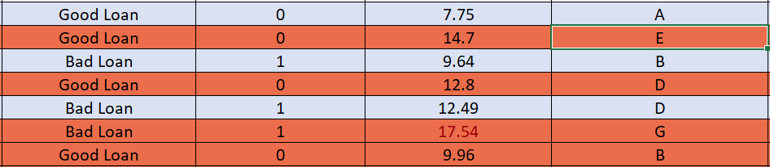

15. Loan Purpose Analysis:
Categorize loans by their stated purpose. Which purpose has the highest average loan amount?
- From the PivotTable, the average loan amount by purpose is highest for small_business, followed by debt_consolidation and house.
- The bar chart to the right visualizes this, where the small_business bar is the tallest, confirming it has the largest average ticket size among all purposes.
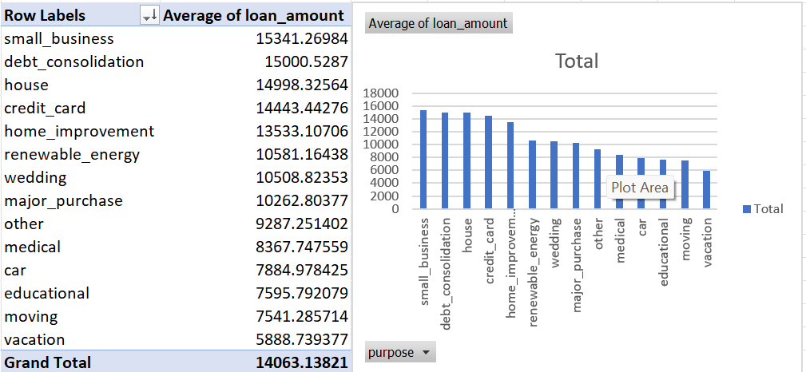

16. Aggregate Loan Analysis by Year:
Summarize total loan amounts, average interest rates, and default rates for each year.
Steps: 1. Summarize Total Loan Amounts by Year
2. Calculate Average Interest Rates by Year
3. Determine Default Rates by Year

- Sum of loan_amount: Total principal issued each year (4,377,660,75 for 2013).
- Average of interest_rate: Typical pricing for that year, around 11–15% depending on the year.
A year‑wise PivotTable was created with year in rows and loan_amount summarized as total and interest_rate summarized as average. This shows that total originations grew strongly after 2011, while average interest rates stayed around 12–15% per year, indicating stable pricing despite rapid portfolio growth.
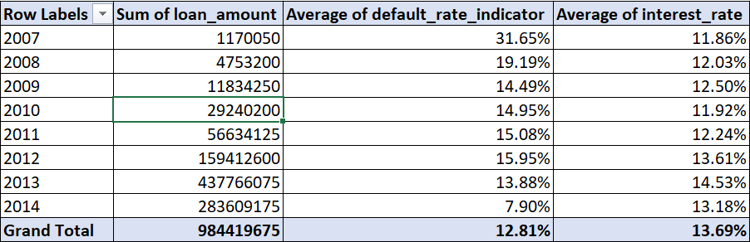

17. Grade-wise Profitability Analysis:
Calculate the profitability of loans (total payments received minus the loan amount) for each grade.

- Sum of profit: Grade C and B show the largest total losses because they probably have the highest total loan volume.

- Average of profit: Loss per loan is worst for Grade E (about −3,165 per loan), meaning E‑grade loans are the least profitable on average, while A/B have smaller losses per loan.

Profitability was calculated per loan as total_pymnt minus loan_amnt, then summarized by grade in a PivotTable. All grades show negative profitability, with the largest total losses in grades B and C and the worst average loss per loan in grade E, indicating that lower‑quality grades are especially unprofitable under the current portfolio performance.
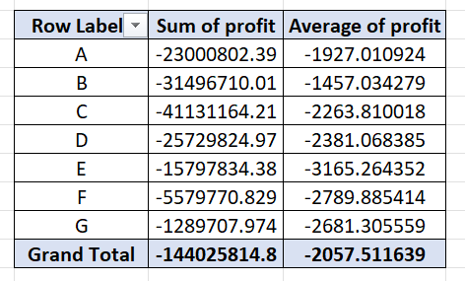

18. Predictive Analysis for Loan Defaults:
Utilize Excel's advanced functions to predict the likelihood of default based on factors like loan amount, income, and employment length.

A simple predictive score was built in Excel using loan amount, annual income, and employment length. The score increases with larger loan amounts and decreases with higher income and longer employment, reflecting research that higher income and stable jobs reduce default risk while larger loans increase it. Loans with the highest scores were highlighted using conditional formatting and treated as having a higher predicted likelihood of default.
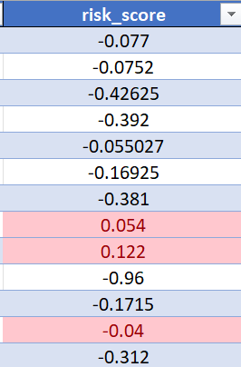

19. Loan Profitability Index Calculation:
Develop a "Loan Profitability Index" (LPI) for each loan, a composite metric that factors in the interest rate, loan amount, loan term, and the loan condition (whether it's in good standing, late, or defaulted). (This can be calculated with available data like interest_rate, loan_amount, loan_term, and loan_condition.)

A custom Loan Profitability Index (LPI) was created in Excel to measure how attractive each loan is, using interest rate, loan amount, loan term, and loan condition. First, the expected interest for each loan was calculated as loan_amount × interest_rate × term_in_years. Then this expected interest was adjusted based on the loan condition: good loans kept 100% of the value, while bad loans were penalized to 50% of the value to reflect higher loss risk. Finally, the LPI for each loan was computed as adjusted_interest divided by the original loan_amount, so higher values indicate more profitable loans relative to their size.

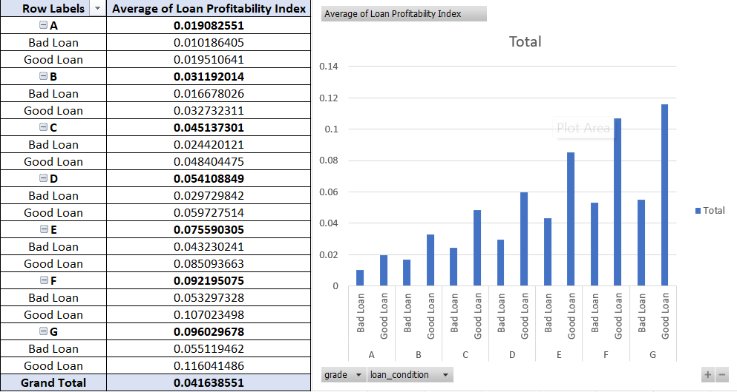

20. Risk-Adjusted Return on Loans:
Calculate the risk-adjusted return on loans for each grade category. This metric should reflect not only the return (in terms of interest received) but also the risk (chance of default).

A grade‑wise risk‑adjusted return metric was calculated using a PivotTable in Excel. For each grade, the average interest rate was taken as the measure of gross return, and a default_rate field (1 for bad/defaulted loans, 0 for good loans) was averaged to estimate the historical default probability. A calculated field then subtracted the default rate from the average interest rate to obtain a simple risk‑adjusted return (e.g., if average return is 17.7% and default rate is 12.9%, the risk‑adjusted return is about 4.8%), highlighting which grades offer better returns after accounting for default risk.

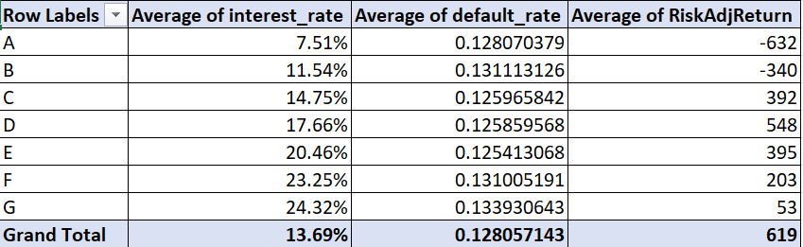

21. Calculating Weighted Average Interest Rate for Each Income Category:
Calculate the weighted average interest rate for each income category, taking into account the loan amount as the weight. (Method: Use a combination of SUMPRODUCT and SUMIF functions.)

Weighted average interest rates by income category were calculated using SUMPRODUCT, multiplying each loan’s interest rate by its loan amount and dividing by the total loan amount within each income group, so larger loans have a bigger influence on the average rate.
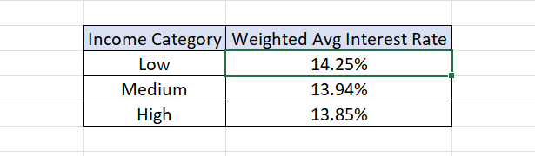

22. Determining the Most Common Loan Purpose for Defaulted Loans in Each Region:
Find out the most frequent loan purpose for loans that have defaulted in each region.
To find the most common default reason by region, an array formula combined IF, MODE, MATCH, and INDEX. For each region, the formula filtered rows to only ‘bad loan’ records, computed the frequency of each purpose, and returned the purpose with the highest frequency as the dominant default reason in that region.
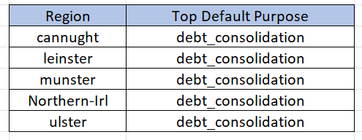

Part III: Building an Excel Dashboard

Key Elements to Include in the Dashboard:

1. Summary Statistics Section: Total number of loans, Average loan amount, Average interest rate, Overall default rate.

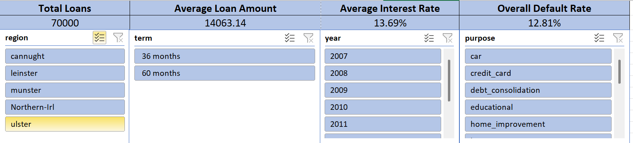

2. Loan Distribution Visuals: Pie charts or bar graphs showing the distribution of loans by region, income category, and loan purpose.

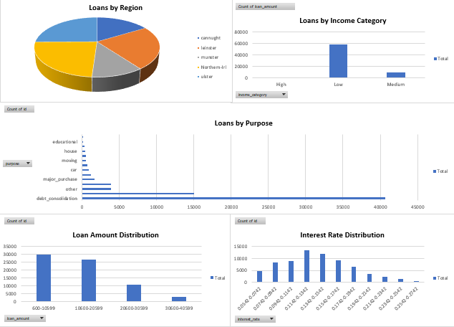

3. Trend Analysis Over Time: Line or area charts displaying trends in loan amounts, interest rates, and default rates over time.
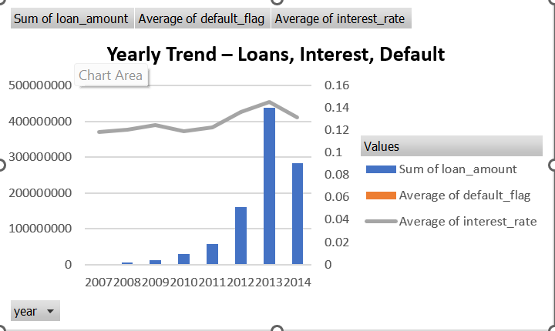

4. Loan Status Overview: Current status of loans (e.g., current, late, defaulted) visualized using a donut chart or stacked bar chart.

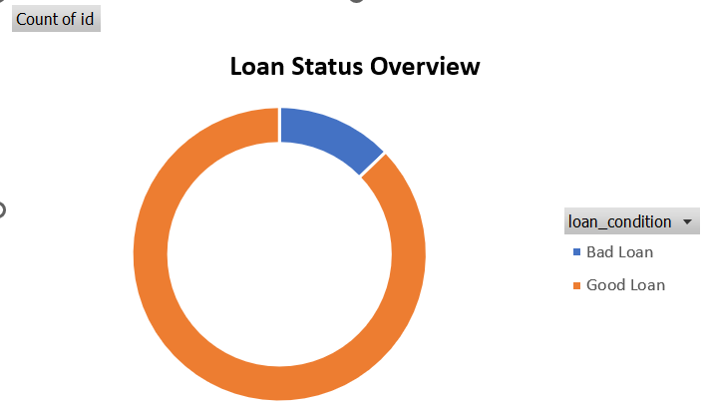

5. Interactive Filters and Slicers: Allow users to filter data based on year, region, loan grade, employment length, etc.

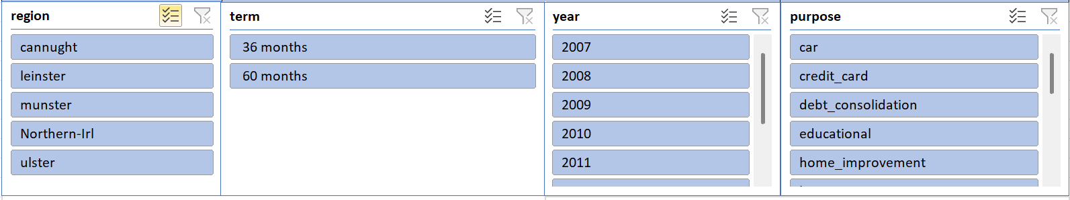

6. Correlation and Analysis Section: Scatter plots showing the relationship between loan amount and borrower's annual income, or interest rate and default rate.

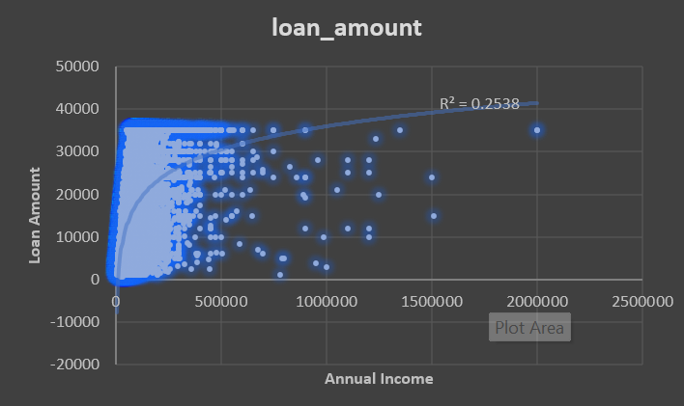

Final Dashboard Image

